Ideation Phase

Brainstorm & Idea Prioritization Template

Date | 18 FEB 2026
Team ID | LTVIP2026TMIDS74685
Project Name | Visualizing Housing Market Trends: An Analysis of Sale Prices and Features using  Tableau
Maximum Marks | 4 Marks

Brainstorm & Idea Prioritization Template:
Brainstorming provides a free and open environment that encourages everyone within a team to participate in the creative thinking process that leads to problem solving. Prioritizing volume over value, out-of-the-box ideas are welcome and built upon, and all participants are encouraged to collaborate, helping each other develop a rich amount of creative solutions.
Use this template in your own brainstorming sessions so your team can unleash their imagination and start shaping concepts even if you're not sitting in the same room.
Reference: https://www.mural.co/templates/brainstorm-and-idea-prioritization
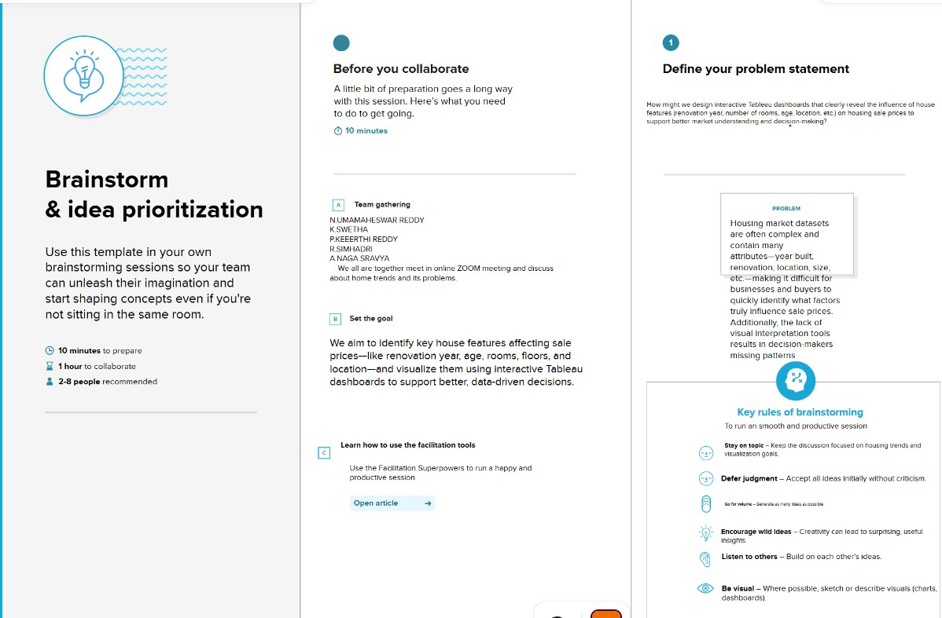
Step-1: Team Gathering, Collaboration and Select the Problem Statement
participants
K.Pravallika, M.Bhavitha, B.Sujithkumar, T.Shariff, K.Guru sai Charan.
Session Goal:
Define the focus of the housing market visualization project.

Problem Statement (How Might We…):
How might we design Tableau dashboards that uncover and clearly communicate key factors affecting house sale prices and trends across features like renovation, age, bedrooms, bathrooms, and floors?
Step-2: Brainstorm, Idea Listing and Grouping

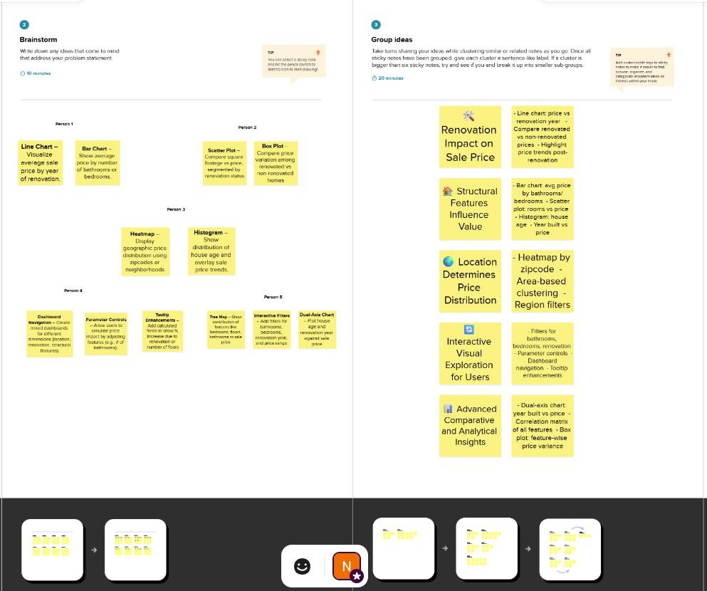
Instructions:
List all ideas generated from the brainstorming session. Then group them into clusters based on themes.
Ideas List: - Show average sale price over years since renovation - Correlate number of bathrooms with price - Cluster house age with number of floors - Heatmap of price distribution by zip code - Use filters for bedrooms/floors/bathrooms - Show trend lines by year built - Bar chart: average price by number of bedrooms - Compare renovated vs non-renovated price growth
Grouped Clusters:
Cluster Theme Ideas
Renovation Impact Show avg price over years since renovation, compare renovated
vs not

House Age & Structural Features
Cluster house age with floors, show trend lines by year built

Cluster Theme Ideas
Bathrooms/Bedrooms Impact Correlate bathroom counts, avg price by bedrooms Location-based Price Analysis Heatmap by zip code, regional filters
Dashboard Interactivity Filters, dropdowns, slicers

Step-3: Idea Prioritization
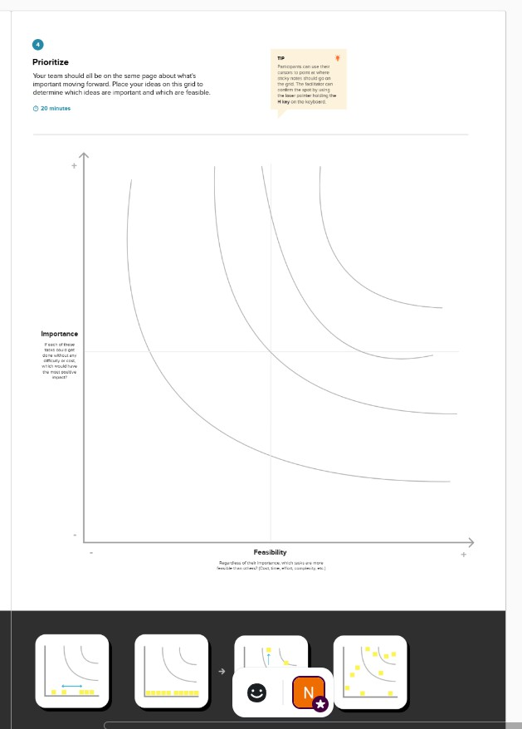

Step 3: Idea Prioritization Grid
Evaluate ideas based on feasibility and importance.

Idea Cluster Feasibility Importa nce
Final Priority

Renovation Impact High High Top Priority

Idea Cluster Feasibility Importa nce
Final Priority

House Age & Structural Features Medium High Priority 2 Bathrooms/Bedrooms Impact High Medium Priority 3
Location-based Price Analysis Medium Medium Optional / Future Enhancements Dashboard Interactivity High High Essential – include in all dashboards

